**Assignment-7 [Packages]**

[Submitted by **Malika Hafiza Pasha**]

**Implement in Python**

1. Write a function that eliminates all the punctuation symbols, html tags, etc. in the given text. It should return plain text containing alpha numeric characters.

Text=”NumPy, <hl> pandas ?, matplotlib; re, seaborn# SciPy* etc.. are few & Python packages) that are used) frequently (/re package | will be used @ for text% preprocessing$.”

**Answer:** [Python file is attached with the assignment file]

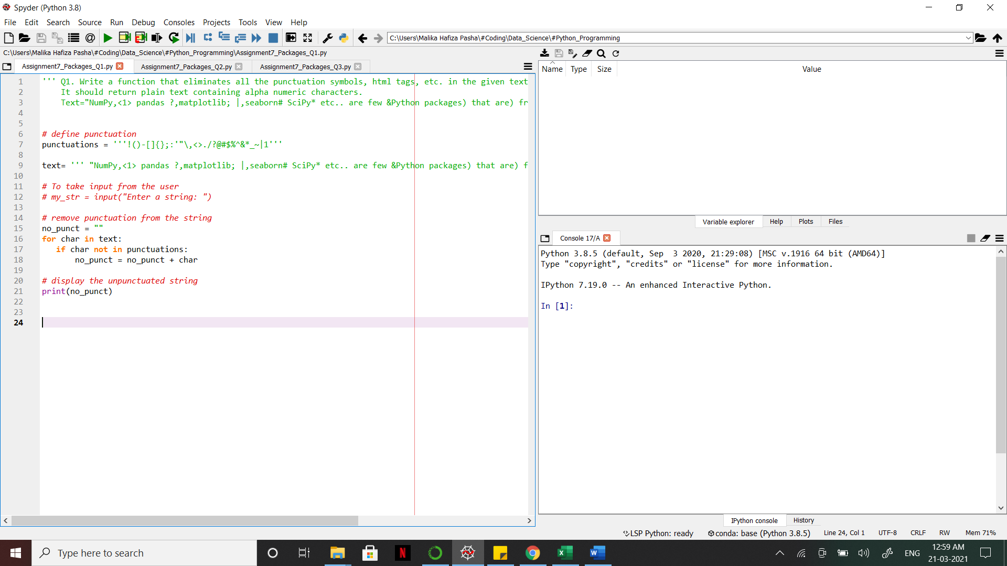

1. For the dataset “Indian_cities”,
2. Find out top 10 states in female-male sex ratio
3. Find out top 10 cities in total number of graduates
4. Find out top 10 cities and their locations in respect of total effective_literacy_rate.

**Answer:** [Python file is attached with the assignment file]

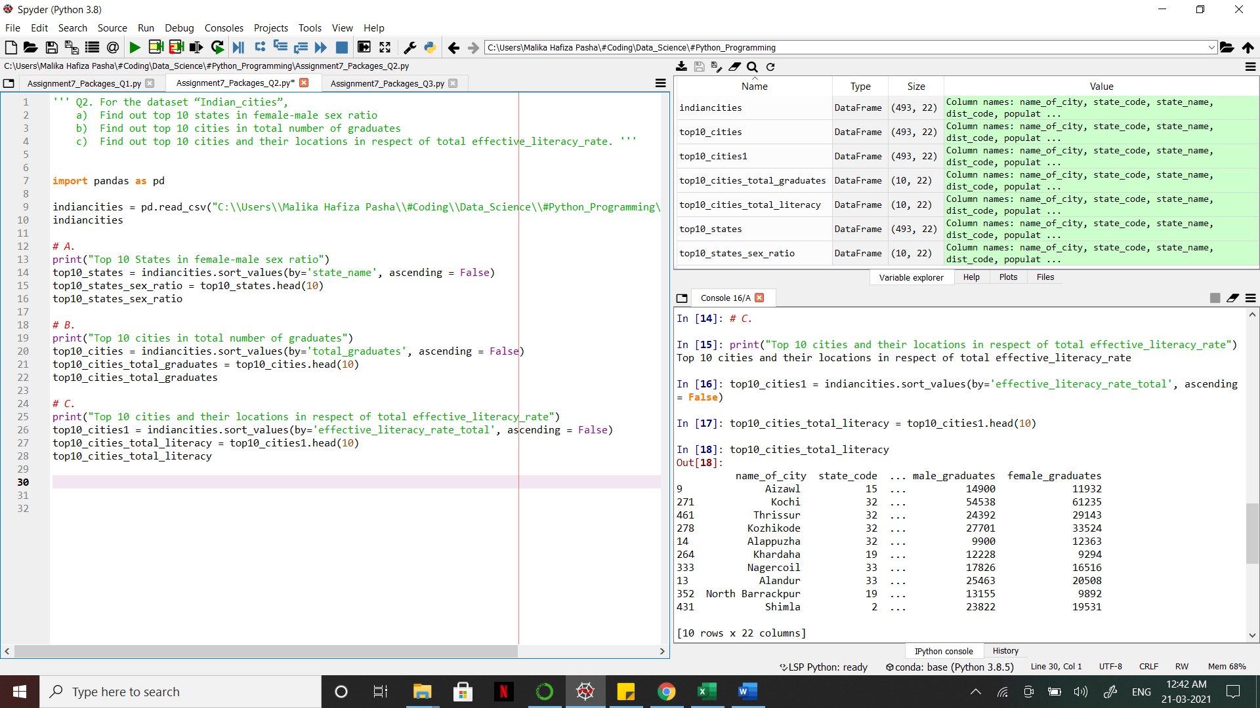

1. For the data set “Indian_cities”
2. Construct histogram on literates_total and comment about the inferences
3. Construct scatter plot between male graduates and female graduates
4. Construct Boxplot on total effective literacy rate and draw inferences
5. Find out the number of null values in each column of the dataset and delete them.

**Answer:** [Python file is attached with the assignment file]

